Dear customer,

we would like to inform you about the changes to the Gold Plus Rewards loyalty cards.

The combination of the decreasing demand for the printed loyalty card and the current age where sustainability plays a prominent role, has made us decide to stop the production of Hertz Gold Plus Rewards loyalty cards und der Hertz Auth. Rep. cards.

What will change for you?
- If you currently own a Hertz loyalty card, you can continue to use it for your future rentals.
- Members can print their membership cards at any time on hertz.at. Click on "My account" and select "Print customer card" in your Gold profile.
- Reprinting or reprinting of unreadable or damaged cards is no longer possible.

With regard to Gold Plus Rewards HCC Cards, the physical presence of the card at the counter is not required as the HCC account details are stored digitally in the Gold Profile.

Ending the issuance of printed loyalty cards has no further influence on your status or reservation method. As always, you can enjoy the benefits of Gold Plus Rewards.

Procedure for new Gold Plus Rewards applications:

- An email address must be provided with the Gold application. I have attached a new application, the marked data must be entered.
- The customer will receive an email from Hertz after we have registered them.

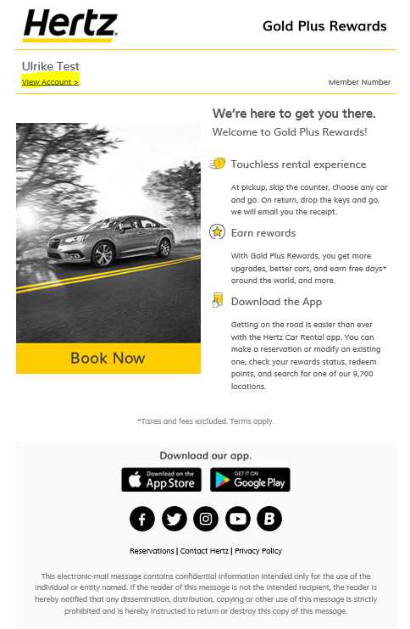

- Once we have linked the customer to their Hertz account, they will receive another email directly from us with their Gold Plus Rewards number. (This can take up to 24 hours).

- With the Gold Plus Rewards number, they will need to enter the link highlighted above and complete their profile (create a password and submit a consent form).

